Thanks for working with our company…..We will provide you with the best service ever.

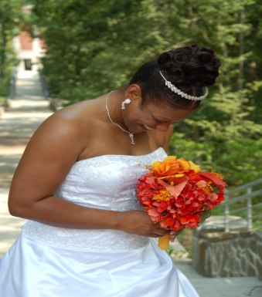  TMFPHOTOGRAPHY | Dr. Tiffany Fuller  www.tmfphotography.com  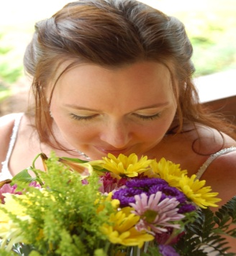  Thank you for your business!  INVOICE
TMFPHOTOGRAPHY
Checks Written Out To: TMFPHOTOGRAPHY
“The Digital Experience”

Dr. Tiffany Michelle Fuller-Owner of TMFPHOTOGRAPHY  Mailing Address:  3692 McGinty Drive  Greensboro, NC 27406  Phone 336-908-0231  T_full@yahoo.com | 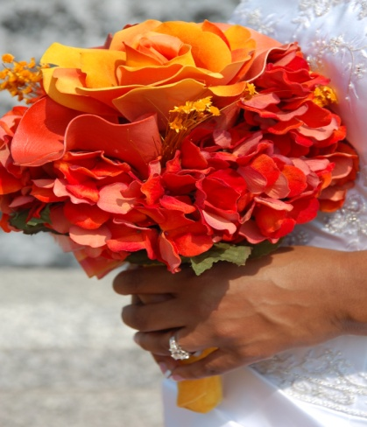  Dr. Tiffany M. Fuller

To | Your Name____________________  Wedding Date_____________________  Wedding Time_____________________  Wedding Location__________________  Reception Location_________________  Arrival Time for Photographer_____________________  Departure Time for Photographer___________________  Checks Written Out To: TMFPHOTOGRAPHY  You Can Pay On-Line (www.tmfphotography.com) On Home Page With Credit Card | Your Phone Number:______________  Email__________________________  Time ______________________________  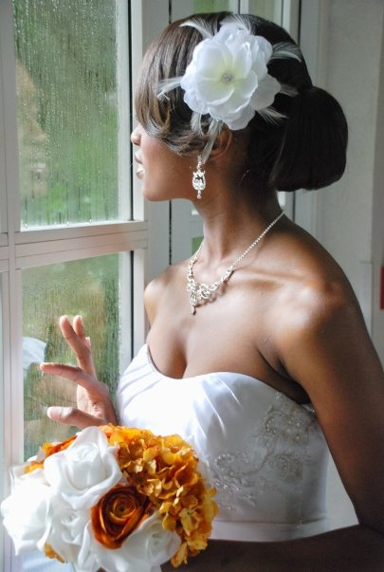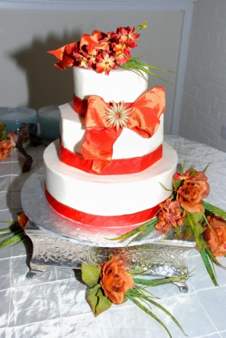
 | TMFPHOTOGRAPHY CONTRACT | P.S. Three of your pictures will be featured on www.tmfphotography.com. If that is ok?  Sign Here:___________________  We also offer $150.00 per Hour for all Events.

salesperson | Job | payment terms | due date
Tiffany Fuller | Photographer | Due on receipt | 7 Days Before Wedding

Qty | Description | unit price | line total
You can copy and paste from the website.

Deposit for all Wedding is New $100 Non-Refundable-You must make the deposit to hold the wedding date.

Deposit Information For Weddings:
There is a $100 Non-Refundable Deposit to hold the date for your wedding. All weddings must be under contract and paid in two weeks prior to the wedding date. If the amount is not paid in full by the two weeks; the contract will be void. The photographer will not try to contact and bride for pay or try to allow them to make payment arrangements. The contract will no longer be valid.
If the wedding is outside of Greensboro/Burlington/Graham/Mebane, NC; there will be a ($50.00 gas fee) charged to the bride. If the wedding is outside of NC, the bride must pay ($100.00) gas fee and the bride must get the photographer a hotel for one night).
The bride is allowed to change the date of the wedding, but will have to get married within the same year as the date the contract was written or the contract is once again void. The bride can’t carry the contract over into another year. The photographer may not be available on the new date.
Dr. Tiffany fuller
336-908-4933
Client Signature____________________Date____________________
Client Signature____________________Date____________________

Signed By: Owner Tiffany M. Fuller
P.S. Three of your pictures have been featured on WWW.TMFPHOTOGRAPHY.COM

Thanks Once Again: TMF

List of Wedding Pictures

Getting Ready
- Bride's clothes hanging on the wardrobe, on the bedpost, or over a chair
- Bridesmaids doing bride's hair and makeup
- Bride and bridesmaids getting dressed, applying makeup
- Mom helping bride with one last detail, such as veil
- Full-length shot of bride in gown checking herself out in mirror
- Detail of clothing, shoes, garter, something borrowed, something blue
- Touching shot of bride with parent/s and/or stepparent/s
- Touching shot of bride with sibling/s
- Bride hugging honor attendant
- Bride with bridesmaids
- Bride with all the women
- Groom getting ready with Dad and pals (tying the tie is a classic)
- Touching shot of groom with parent/s and/or stepparent/s
- Touching shot of groom with sibling/s
- Groom with his arm affectionately around best man
- Groom with all the groomsmen
- Groomsmen putting on boutonnieres or bowties
- Intimate shots of bride and groom chatting with/crying with/hugging parents and siblings pre-ceremony
- Dad whispering last-minute advice to groom
- Groom ready to go
- Bride ready to go
- Bride and groom separately making their way to the ceremony (in a limo backseat, hailing a cab, walking down the street/hall/stairs)

The Ceremony
- Guests streaming into the site
- Ushers escorting guests to their seats
- Ushers escorting moms to their seats (Christian wedding)
- Close-up of groom's adorably nervous mug waiting for his other half
- Bridesmaids and groomsmen walking down the aisle
- Flower girl and/or ring bearer entering
- Honor attendant walking down the aisle
- Grandparents walking down the aisle (Jewish wedding)
- Wedding party waiting at the altar
- Groom walking down the aisle
- Bride and Dad/escort/parents (Jewish wedding) walking down the aisle
- Close-up of bride just before she makes her entrance
- Bride and groom at the altar
- Altar or canopy from the back during ceremony
- Wide shot of audience during ceremony, from bride and groom's point of view
- Faces of bride and groom as they exchange vows
- Close-up of bride's and groom's hands as they exchange rings
- The kiss
- Bride and groom proceeding up the aisle, guests' smiling faces at their sides
- Bride and groom outside ceremony site
- Congrats shots: bride and groom hugging, laughing, and crying with good friends and family
- Bride and groom leaving ceremony site
- Bride and groom in limo backseat

